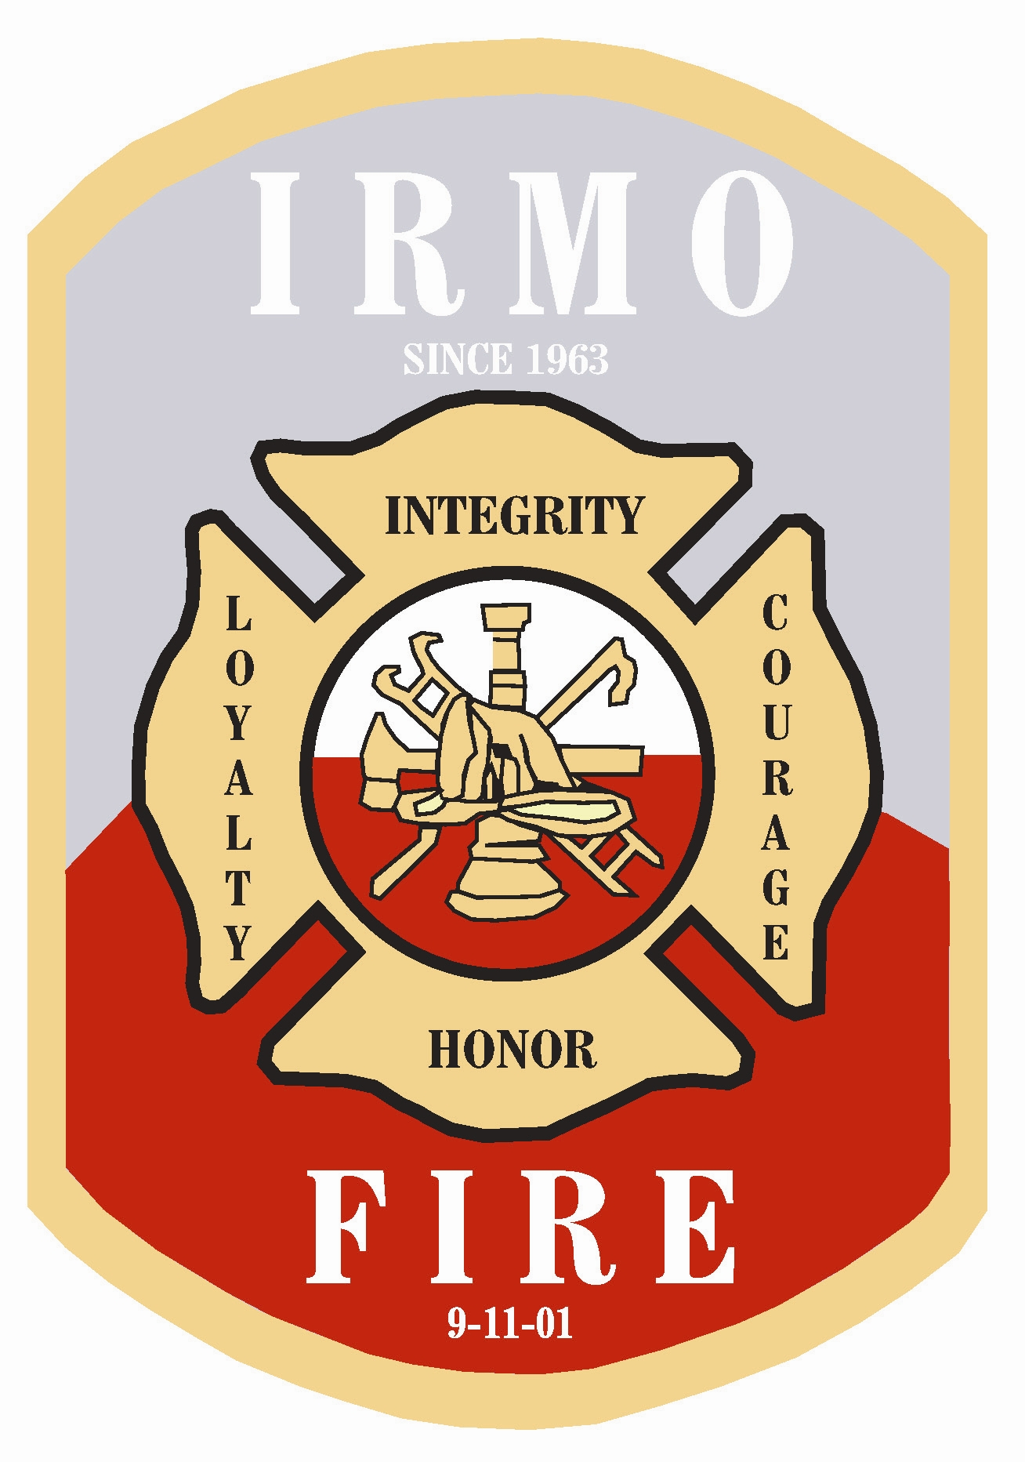
IRMO FIRE DISTRICT
Serving Since 1963
BURN PERMIT
As outlined in the legally adopted 2015 International Fire Code. A person shall not kindle or maintain or authorize to be kindled or maintained any open burning unless a permit is obtained from the Fire Official prior to kindling a fire.
All municipal, county and state laws regarding air quality and toxic materials still apply. A signature on the bottom of this permit indicates that these conditions have been reviewed and the person performing the burning is aware of all applicable laws and will abide by them. Any person who violates any of the provisions of this permit shall be guilty of a misdemeanor and shall be subject to a fine or imprisonment in accordance with municipal and/or county law.
NOTE: UNDER NO CIRCUMSTANCES SHALL ANYTHING OTHER THAN NATURAL VEGETATION BE BURNED
- no burning may take place within 75 feet of any structure including a fence.
- no burning shall take place within 75 feet of any lot line
- burning inside an approved burning container (55gallon steel drum with mesh cover to prevents embers and sparks from rising in the heated air currents) shall not be closer than 75 feet from any structure, and not within 75 feet of any lot line.
- any production of smoke shall stop between sunset and sunrise. Fires MUST BE fully extinguished.
- fires shall be attended at all times by a competent person
- a method of extinguishing the fire completely shall be available at all times while burning
- only materials allowed by law shall be burned such as yard debris. Dimensional lumber, plywood, chipboard, etc. is not considered to be natural vegetation and the burning of such materials is not permitted.

All burn permits expire one week from issue date. No extensions are allowed.
H.Q. Phone: (803) 798-4979 NL Phone: (803) 781-7178
6017 St. Andrews Road, Columbia, SC 29212
- Lincreek Dr. Columbia, SC 29212
IRMO FIRE DISTRICT
Serving Since 1963
- due to atmospheric conditions, changes in weather or a complaint received from residents, this permit may be revoked
- all municipal, county and state criminal laws apply when burning results in damages to the property of others
- a burn permit is not required for kindling a fire to cook food for immediate consumption, providing the fire does not exceed 3 feet in diameter.
- a cooking fire may only have wood or charcoal as fuel. Any other materials are considered a violation of this ordinance
By signing this document, the signer agrees that the fire department has the right to enter the property and determine if the cooking fire has the appropriate materials burning.
If all rules and regulations are being followed, and a complaint is lodged due to any reason, this permit will be revoked.
If you live in Lexington County, you must call 1-800-705-8613 and notify SC Forestry that you are going to burn. The Richland County number is 1-800-517-9638

____________________ _________________ ____________________
Permit Number Date Issued Expiration Date

______________________ _____________________________
Permit issued to Address of burning

_____________________ ______________________________
Contact number Second contact number

________________________________ ______________________________
Issued by (IFD Staff Member) Signature of Property Owner/Resident
All burn permits expire one week from issue date. No extensions are allowed.
H.Q. Phone: (803) 798-4979 NL Phone: (803) 781-7178
6017 St. Andrews Road, Columbia, SC 29212
117 Lincreek Dr. Columbia, SC 29212

